REVERSE ENGINEERING REPORT
Arduino-Based Keypad Calculator
Simulation and Functional Analysis

Prepared by: group no 54
Class / Department: VLSI
Institution:kiet

1. Introduction
This report presents the reverse engineering and functional study of an Arduino-based calculator implemented in a circuit simulation. The system uses an Arduino Uno as the controller, a 4×4 matrix keypad for user input, and a character LCD to display the entered values and calculated result. The purpose of the study is to understand how the physical modules are connected and how the complete system converts key presses into a displayed calculation.

2. Objective of the Project
- To identify the main hardware modules used in the calculator.
- To understand the input, processing, and output stages of the system.
- To examine the keypad, Arduino Uno, LCD, power, and wiring connections in the simulation.
- To describe the expected program flow for performing arithmetic calculations.
- To observe the system response through a simulated calculation.

3. Product / System Overview
The calculator is a small embedded system. The user presses number and operation keys on the keypad. The Arduino reads the key press, interprets the selected operation, performs the calculation in software, and sends text to the LCD. The displayed example in the supplied simulation shows a result of 7.00.
Item | Description
System name | Arduino-based keypad calculator
Controller | Arduino Uno
Input device | 4×4 matrix keypad (0–9, A–D, * and #)
Output device | Character LCD module
Development / simulation environment | Circuit simulation image supplied by the user
Power source | USB connection shown for the Arduino Uno; exact simulation supply settings are not specified
Primary function | Accept key input, calculate an arithmetic result, and display it

4. Physical / Visual Inspection
The supplied simulation image was inspected without assuming any unseen components or settings.
- Arduino Uno board with digital and analog pin headers.
- A 4×4 keypad connected to the Arduino through an eight-wire connector.
- A character LCD connected to the Arduino using multiple signal and power wires.
- A resistor is visible near the LCD wiring; its exact value and precise function cannot be confirmed from the image alone.
- USB cable is shown connected to the Arduino Uno.
- The LCD is displaying a numeric value and a result-like value, with “7.00” visible.

5. Simulation Photograph
Figure 1. Supplied Tinkercad-style circuit simulation of the Arduino keypad calculator.
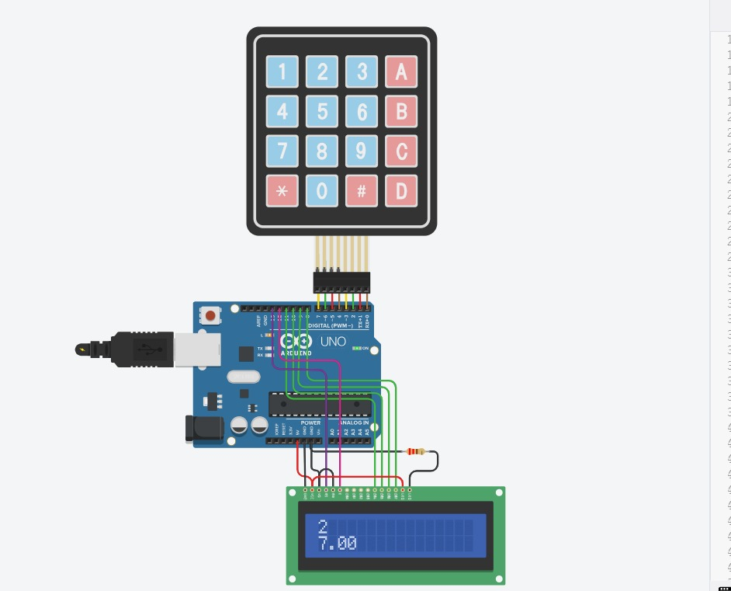

6. Main Components and Their Functions
Component | Role in the circuit | Functional explanation
Arduino Uno | Controller / processing unit | Reads keypad signals, processes the selected operation, and controls the LCD.
4×4 matrix keypad | Input unit | Provides number keys and function keys. The Arduino identifies a pressed key by scanning keypad rows and columns.
Character LCD | Output / display unit | Shows entered values, operation information, and the calculated answer.
Connecting wires | Electrical interconnections | Carry power, ground, and digital control/signals between modules.
Resistor near LCD | Possible current limiting or contrast-related circuit element | Its exact role cannot be confirmed from the picture alone; verify the circuit diagram or simulation properties.
USB cable | Power and programming connection | Provides a connection to the Arduino; the exact power configuration depends on the simulator setup.

7. Functional Block Diagram
User presses a key
↓
4×4 Keypad
↓
Arduino Uno — key scanning and calculation logic
↓
Character LCD
↓
Displayed value / result

8. Working Principle

Step 1 — Input
The user presses a key on the matrix keypad. The keypad does not calculate by itself; it only provides a key signal.

Step 2 — Key detection
The Arduino scans the keypad rows and columns and identifies which key has been pressed.

Step 3 — Data handling
The program stores the entered digits and recognizes operation/function keys according to the code written for the project.

Step 4 — Calculation
The Arduino performs the selected arithmetic operation in software. The exact supported operations and key mapping depend on the program, which was not included with the image.

Step 5 — Display
The Arduino sends characters and the result to the LCD so the user can read the output.

9. Input–Processing–Output Analysis
Stage | Hardware / software element | What happens
Input | 4×4 keypad | Key press is supplied to the controller.
Processing | Arduino Uno and calculator program | Key is decoded, values are stored, and an arithmetic result is calculated.
Output | Character LCD | Text and the result are shown to the user.
Power / interconnection | USB, power and ground wires | Supplies the board and provides electrical paths between modules.

10. Observations from the Simulation
- The keypad, Arduino Uno, and LCD are connected as one integrated circuit.
- The keypad has sixteen buttons arranged in four rows and four columns.
- The LCD appears to show “7.00”, demonstrating a numeric display output in the provided screenshot.
- The Arduino Uno is the central unit linking input and output.
- The screenshot confirms the visible arrangement, but does not by itself prove every arithmetic operation or error condition works.

11. Engineering Analysis and Design Considerations
Consideration | Engineering significance
Pin allocation | The keypad needs eight row/column connections; LCD pins also consume Arduino pins unless an interface module is used.
Display readability | LCD contrast and correct power/ground connections are important for readable output.
Input reliability | The program should handle key bounce and prevent a single press from being read repeatedly.
Calculation accuracy | The program should define how decimals, division by zero, and repeated operations are handled.
Wiring accuracy | Incorrect pin mapping can prevent keypad detection or cause missing/incorrect LCD output.
Power and grounding | All modules need suitable power and a common ground where required by the circuit design.

12. Testing Plan
Test | Procedure | Expected result
Power-on test | Start the simulation. | Arduino and LCD initialize without visible wiring errors.
Digit input | Press a number key. | The selected digit appears or is stored as specified by the program.
Arithmetic test | Enter two numbers and an operation. | The calculator returns the correct result for the programmed key mapping.
Clear / reset test | Press the assigned clear key. | The current entry or calculation is cleared as designed.
Invalid operation | Attempt division by zero, if division is supported. | The program handles the case safely rather than displaying an uncontrolled or misleading result.

Testing note: These are recommended verification tests. They should be performed in the simulator before claiming that each function has passed.

13. Limitations
- The Arduino source code was not included, so the exact key mapping and supported operations cannot be verified.
- The exact LCD type, pin assignments, resistor value, and wiring list are not fully legible from the screenshot.
- Only one simulation screenshot was supplied; no separate screenshots of individual test cases were available.
- The shown display value is an observation from the image, not a complete test record.

14. Conclusion
The Arduino-based keypad calculator demonstrates a basic embedded-system architecture consisting of an input module, a controller, and an output display. The keypad supplies user commands, the Arduino Uno processes them using programmed logic, and the LCD presents the result. Reverse engineering this system helps explain how hardware interconnections and software work together. The next step is to verify the pin map and source code, then run the recommended tests and capture additional simulation screenshots for each major function.

